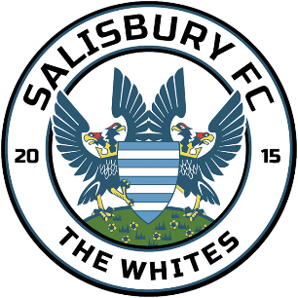

Salisbury Football Club

Adult Player Code of Conduct

Implementation Date: | 20th August 2025
Agreed By: | Salisbury FC Board of Directors
Next Review Date: | 21st August 2026

Salisbury Football Club fully supports the FA’s Code of Respect, we believe that we all have the responsibility to promote the highest standards of behaviour. Adult players have a significant role to play in this. All adult players should follow this code of conduct and treat your team, other players, match officials with Respect.
Adult Players on and off the field, I will:
- Stick to the rules and celebrate the spirit of the game.
- Always show respect to everyone involved in the game.
- Never engage in public criticism of the Match Officials and abide by their final decision.
- Win or lose with dignity. Shake hands at the end of the game.
- Be aware of the potential impact of bad language on others.
- Never engage in abusive language, bullying or intimidating behaviour.

I understand that if I do not follow the code, I may:
- Be asked to apologise to whoever I’ve upset.
- Receive a formal warning.
- Be required to attend a FA education course.
- Be dropped, substituted, or suspended from training.
- Not be selected for the team.
- Be sanctioned by the club in line with player's contract.
- Be asked to leave the club and / or issued a fine.

